Game Design Document

Fill up the following document

1. Write the title of your project.

The Dog’s Meal

1. What is the goal of the game?

The goal of the game is to make the dog eat the food and avoid the birds falling form the sky.

1. Write a brief story of your game.

The dog is hungry, so it is the player’s job to feed it. The objective is to make the dog eat the food and not the birds. You have been given two lives to feed the dog.

1. Which are the playing characters of this game?

* Playing characters are the ones who respond to the user based on the input from the user.
* Cars, monkeys, dinos, wizards, etc., are the playing characters in the game.

|  |  |  |
| --- | --- | --- |
| Number | Character Name | What can this character do? |
| 1 | The dog | It can move around on the x-axis and “eat” the food. |
| 2 |  |  |
| 3 |  |  |
| 4 |  |  |
| 5 |  |  |
| 6 |  |  |
| 7 |  |  |
| 8 |  |  |

1. Which are the Non-Playing Characters of this game?

* Non-Playing characters are the ones that don't have an action or behavior when the user interacts with the game.
* Hurdles, stones, bananas, coins, etc., are non-playing characters in the game.

|  |  |  |
| --- | --- | --- |
| Number | Character Name | What can this character do? |
| 1 | birds | It falls from the sky at a set y velocity |
| 2 | food | It falls from the sky at a set y velocity |
| 3 |  |  |
| 4 |  |  |
| 5 |  |  |
| 6 |  |  |
| 7 |  |  |
| 8 |  |  |

Draw your imagination of this game. What does this game look like?

* Draw the game either on your computer or on paper.
* Add images of the game scenes to show each of the playing and non-playing characters at least once.

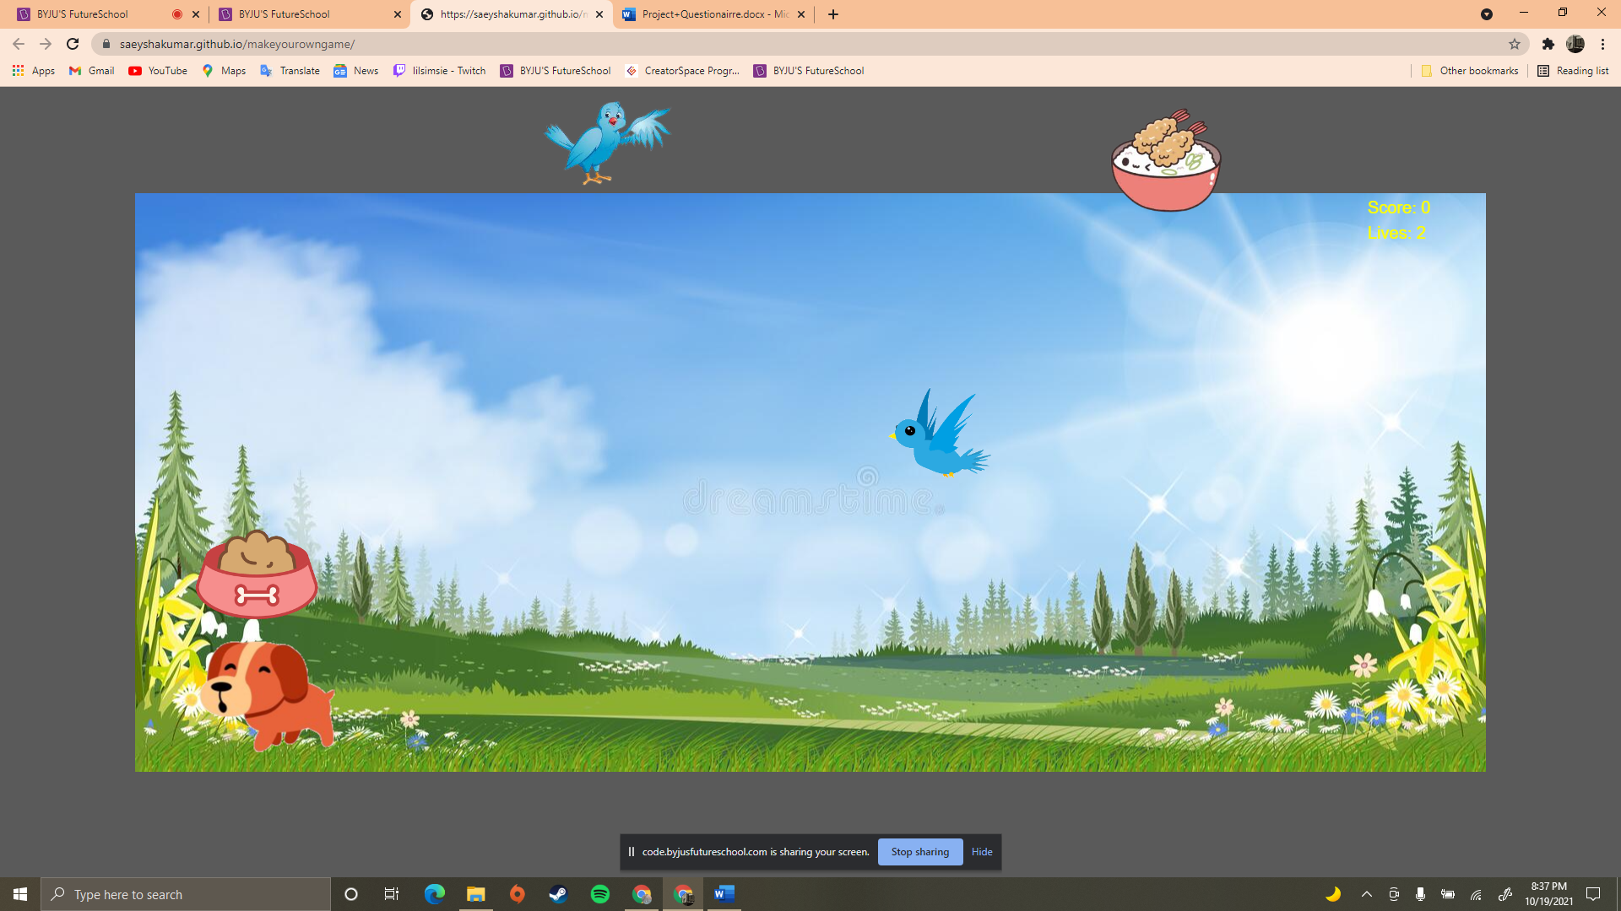

How do you plan to make your game engaging?

I will make my game engaging by having the birds and food fall faster when you gain more points.